|  |  |  |  |  |  |  |
| --- | --- | --- | --- | --- | --- | --- |
| **:LPNW** | **::LPSW** | **::MPSW** | **:LPN** | **::MPW** | **::LPW** | **:LPNE** |
| **::LPS** | **:MPNW** | **::SPSW** | **:MPN** | **::SPW** | **:MPNE** | **::LPNW** |
| **::MPS** | **::SPS** | **:SPNW** | **:SPN** | **:SPNE** | **::SPNW** | **::MPNW** |
| **:LPW** | **:MPW** | **:SPW** |  | **:SPE** | **:MPE** | **:LPE** |
| **::MPSE** | **::SPSE** | **:SPSW** | **:SPS** | **:SPSE** | **::SPN** | **::MPN** |
| **::LPSE** | **:MPSW** | **::SPE** | **:MPS** | **::SPNE** | **:MPSE** | **::LPN** |
| **:LPSW** | **::LPE** | **::MPE** | **:LPS** | **::MPNE** | **::LPNE** | **:LPSE** |

What is Pyramid Love?

Pyramid Love is an icon font for the Pyramid Arcade game system. If you want to write good-looking rules for a pyramid game, with line diagrams like in the Arcade rules, this is a way to do that.

Pyramid Love is a little bit different from most icon fonts. The symbols don’t replace regular letters and numbers. There are a few reasons for this. First of all, there are way too many icons – over 300. Second, if you replace letters, word processors think you’re typing letters. If they’re after a period or a new line, Word will helpfully capitalize them. If they happen to be in a sequence that’s close to a common word, it will automatically correct them. In both cases, you have to change something back, which is a hassle that we avoid under the new system. If you’ve used v1.0 of Pyramid Love, this is a change – I hope a welcome one.

Insert Symbols

The easiest way to put a symbol in your document is through the Insert Symbols menu. In Word, that’s Insert > Symbol > More Symbols, in LibreOffice Writer it’s Insert > Special Character. Make sure the font’s set to Pyramid-Love, then scroll down past the alphanumeric characters until you find the symbol you’re looking for and double-click to insert it into the document.

Ligatures

Another way to add a symbol is to use a ligature. Each symbol has at least one word that it will automatically replace, if you have ligatures enabled. They’re almost always turned off by default, and how you turn them on depends on what word processor you use. **I don’t know how to make them work in OpenOffice/LibreOffice. If you do, tell me.** In Word 2016, you do it from “Text Effects and Typography,” which you can find here:

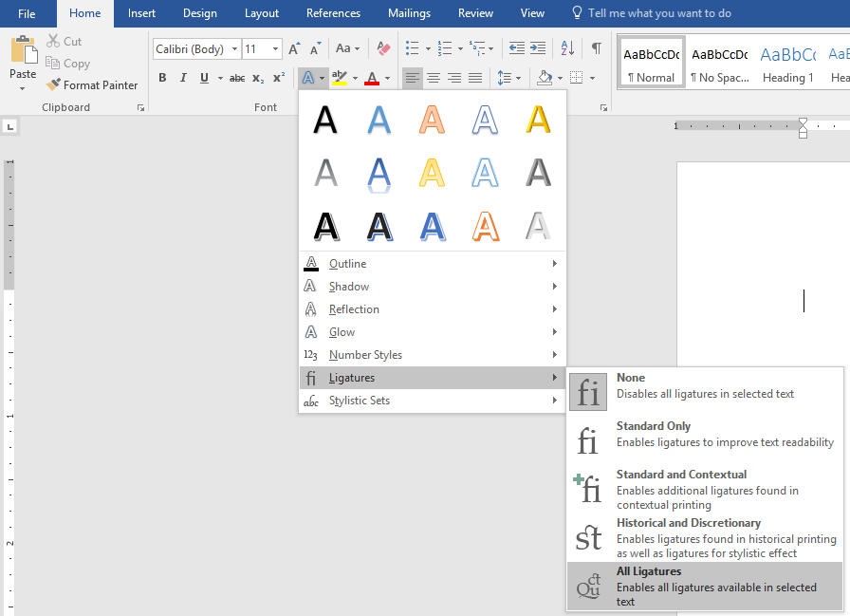

For pretty much everything except for the glyphs of pyramids, you just type a colon followed by their name. For example, to create the  symbol, type :WorldWarFive . To create the  symbol, type :LightningRecycle. To create the  symbol, type :5by5. I can’t list them all here. There’s a complete list in demo.html, in the Demo folder. They also follow consistent rules:

* They always start with a colon “:”
* If they have more than one word, they’re always CamelCased – that is, words inside a ligature all start with a capital letter, and aren’t separated by spaces.

If you’re trying to use these, I recommend guessing once or twice, then looking it up in demo.html.

Ligatures for Pyramids

The ligatures for the pyramid glyphs are considerably more useful, and I would say easier. There’s no guessing, memorization, or lookup. However, the rules are just a little more complicated.

* To make a pyramid, you type S, M, or L in accordance with its size
* All ligatures start with colons. These are ligatures, they start with a colon.

|  |  |
| --- | --- |
| :L | :L  (Large) |

* To make a stack, type up to three pyramids in top-to-bottom order

|  |  |
| --- | --- |
| :SLL | :SLL  (Small-Large-Large) |
| :LMS | :LMS  (Large-Medium-Small) |

* To expand a stack, add an E. Only stacks with nesting can be expanded

|  |  |
| --- | --- |
| :LMSE | :LMSE  (Large-Medium-Small Expanded) |

* To use the solid version of the glyph, start with an extra colon “::”

|  |  |
| --- | --- |
| ::LMSE | ::LMSE  (Large-Medium-Small Expanded) |

* To make a pyramid pointing in a direction, type a single pyramid, then P, then the direction
* Pyramids can point in the following directions: N, S, E, W, NE, SE, SW, NW, U, L, R.

|  |  |
| --- | --- |
| ::LPE | ::LPE  (Large Pointing East) |
| ::MPNW | ::MPNW  (Medium Pointing NorthWest) |
| :LPL | :LPL  (Large Pointing Left) |
| :MPU | :MPU  (Medium Pointing Up) |

* In addition to single pyramids, the following stacks are can point up: SM, SL, ML, SML

|  |  |
| --- | --- |
| :SLPU | :SLPU  (Small-Large Pointing Up) |

:SPL :S :SPR

:MPL :M :MPR

:LPL :L :LPR

:SS :SM :SL

:MSE :MM :ML

:LSE :LME :LL

:SSS :SSM :SSL

:SMSE :SMM :SML

:SLSE :SLME :SLL

:MSSE :MSME :MSLE

:MMSE :MMM :MML

:MLSE :MLME :MLL

:LLSE :LLME :LLL

::SPL ::S ::SPR

::MPL ::M ::MPR

::LPL ::L ::LPR

::SS ::SM ::SL

::MSE ::MM ::ML

::LSE ::LME ::LL

::SSS ::SSM ::SSL

::SMSE ::SMM ::SML

::SLSE ::SLME ::SLL

::MSSE ::MSME ::MSLE

::MMSE ::MMM ::MML

::MLSE ::MLME ::MLL

::LLSE ::LLME ::LLL

Strengths and Limitations

Pyramid Love is good at simple things. If you want to use some component icons to pretty up your Equipment section, or reference the lightning dice symbols in your rules, we’ve got you covered. It’ll be easy. If you’re making a setup diagram or gameplay example, it depends on what you’re trying to do. Some diagrams are pretty easy, others are hard or impossible.

If you need to show more than one color of pyramid in a stack, you can’t. Stacks are one character, each character can only be one color. This is a dead end, fonts have had this limitation for as long as there have been fonts. I am sorry.

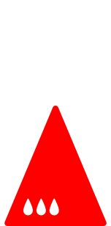::MPR::L::SPL



::MPR::SL

I had to fake one of these koans by importing SVGS and layering them in Word. For little things like this, that’s a decent trick.

If you’re okay on colors, it depends on the shape of your diagram. If it’s a line of stacks, as above, you’ll be okay. If it’s based on a square or rectangular grid, that’s even better - you can use tables, which are simple, flexible, and powerful. I believe these are the best-looking diagrams you can make with Pyramid Love.

If you need to do something with more rotational complexity (like a diagram on a hex grid or the wheel board) or a diagram without a grid (like World War Five), you should use a vector graphics editor.

|  |  |  |  |  |  |  |  |
| --- | --- | --- | --- | --- | --- | --- | --- |
|  |  |  |  |  | :MPW | :LPW | :LPW |
| ::MPE | ::SPE | ::SPE |  |  | :SPW | :MPW | :LPW |
| ::LPE | ::MPE | ::SPE |  |  | :SPW | :SPW | :MPW |
| ::LPE | ::LPE | ::MPE |  |  |  |  |  |

Pyramid Love loves chess boards.

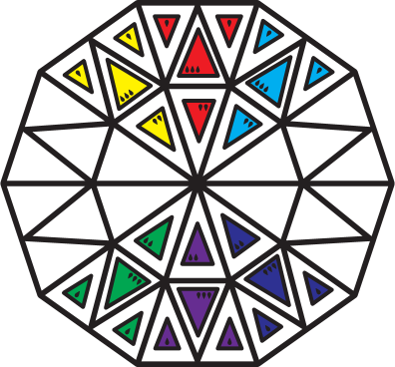

I had to do this in Illustrator. It was not at all complicated to do in Illustrator.

Doing This the Hard Way

There’s no way around this: icon fonts are a hack. They’re a pretty convenient hack, but there’s a reason most people use a vector graphics editor like Illustrator or Inkscape instead of Word for this. These tools are much more flexible, and if you know how to use them, much faster. The only advantage to the icon font, instead of one of these programs, is that you probably already know how to use Word. If you already know a vector graphics editor, or if you feel up to learning something a little more complex, you should definitely use a vector graphics editor to make your diagrams. You’ll have a much better time.

If you take that route, the zip includes two different sets of .svg files to work with. The folder “UsefulSVG” is probably the one you want – it has clean copies of the stuff you’re most likely to want to edit. The folder “SVG” has .svg files for every icon in the font, but they’ve been set up for inclusion in the font, which which is a pretty destructive process (you convert them a single layer of black-filled outlines, with no stroked paths.) For stuff like the spade symbol this really doesn’t make any difference at all, but for pyramids you really want to be able to edit the stroke width and stuff. Use the ones in “UsefulSVG” if you can.

Contributions & Requests

Pyramid Love is under (semi)-active development. If you have an idea for something you would like me to add, or you’d like to contribute to the project, you can find me on github, BGG, the Starship Captains group, or at [loulessing@gmail.com](mailto:loulessing@gmail.com).

Use However You Want

The zip has a lot of stuff in it apart from fonts. If you want to work with SVG or PNG images instead, you can. If you want to make changes to the font itself, I’ve included the .json file icomoon.io uses as an export format. You can upload it there and make changes. (It’s free, or at least it was when I wrote this.) If you’d like some of my rougher source files, you can get them from <https://github.com/brisingre/PyramidLove> .

Pyramid Love is released under the OFL, which it inherits from Nunito. What this means, essentially, is that you can use it for anything and change it any way. The only restrictions to speak of apply if you use it create another font. In that case:

* Your font has to use the OFL.
* You can’t sell your font by itself. (You can sell a game or program with your font embedded in it.)
* You can’t call your font Pyramid Love (or Nunito.)

Prior Work

Pyramid Love is built out of pieces of other things. Most of the symbols are from Pyramid Arcade, by Looney Labs. The original graphic design for these was done by Other Studio. A few are from Wikipedia (with permission), a few are wholly original. The text characters are from Nunito SemiBold, by Vernon Adams. (For the curious, the font family used in the Pyramid Arcade rulebook is called Maax.) It was assembled into a font by Lou.

|  |  |  |  |  |  |
| --- | --- | --- | --- | --- | --- |
|  |  |  |  |  |  |
|  |  |  |  |  |  |
|  |  |  |  |  |  |
|  |  |  |  |  |  |
|  |  |  |  |  |  |
|  |  |  |  |  |  |

…